Half Yearly Progress Report on Research Work carried out from 28.03.2014 to 27.09.2014
Name and address of the candidate : P. Mohandass
Reg. No. P8851
PG and Research Dept. of Chemistry
Saraswathi Narayanan College
Madurai-22.

Occupation if any and address : Associate Professor of Chemistry
Saraswathi Narayanan College
Madurai-22.

Name, designation and address of the : Dr. K. Radhakrishnan
Guide Associate Professor of Chemistry
Saraswathi Narayanan College
Madurai-22.

College where the candidate carried : PG and Research Dept. of Chemistry
out the research Saraswathi Narayanan College
Madurai-22.

Whether the candidate has paid annual
Research fee (mention amount, date of : No
remittance, place of bank, etc.)

Detailed one page report on the progress : Separate sheet Attached
of research work carried out by the
candidate (attach separate sheet)

Remark, if any by the guide : Nil

Signature of the candidate Signature of the research supervisor

Half Yearly Progress Report on Research Work carried out from 28.03.2014 to 27.09.2014
Characterization of 5-benzylidenebarbituric acid and its derivatives
All the compounds were characterized as 5-benzylidenebarbituric acid and its derivatives (Fig.1) by ¹H and ¹³C NMR spectral techniques. ¹H and ¹³C spectra were obtained on a BRUKER AMX 400 MHz spectrometer. Chemical shifts of ¹H were measured with the peak of DMSO at δ 2.51 as the internal reference, while those of ¹³C were recorded with the central peak of DMSO at δ 39.90 as the internal reference.
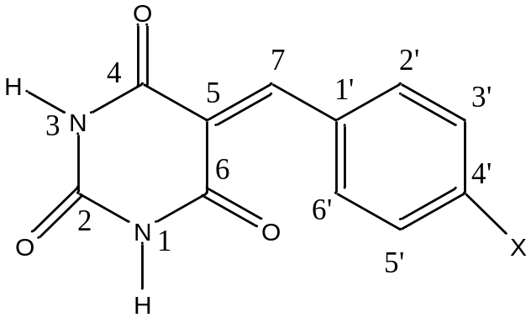
where X is the substituents viz. -OMe, -Me,-OH, -H, -Cl, -Br, and –NO₂

Figure 1

Signature of the research supervisor

